# **CTF Topic: Windows Log Analysis**

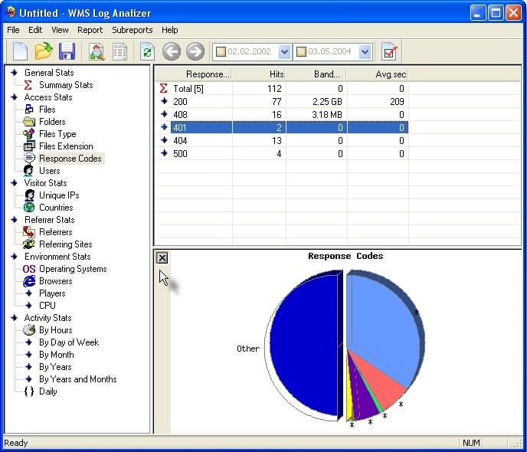

# **Introduction**

Windows log analysis involves examining event logs generated by the Windows operating system to monitor and troubleshoot system activity, security incidents, and application performance. This process helps administrators detect anomalies, ensure compliance, and maintain system integrity by providing insights into various system events and user actions.

# **Scenario**

Your system administrator sent you a screenshot of a log with an error , analyzed it and answered the flags.

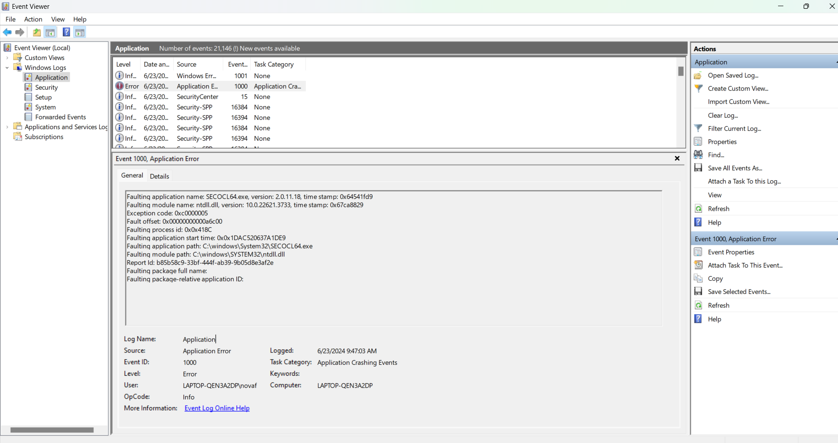

# **Process to Perform**

analyse the logs.

# **Let’s start the Challenge**

# **Question**

**Flag 1 :** What is the version of the faulting application

**Answer :** 2.0.11.18

**Flag 2 :** What is the report id ?

**Answer :** b85b58c9-33bf-444f-ab39-9b05d8e3af2e

# **Hint**

